The following Rotary Club has initiated a global grant application as detailed below. They would welcome any club within District 6440 to partner and thereby fulfill the funding needs. The Principal Contact will be pleased to come to your club and make a presentation about the proposed program. Please convey your interest to the primary contact or to your AG or to Narayan Murarka. Let us help each other to “Do Good in the World.”
_____________________________________________________________________________________
P36 - HealthRays - Guatemala Digital X-Ray Project

International Club Name: Sponsored by District 6440
Point of Contact Name: Pam Kerr Phone: (847) 533-6336 Email: gov.pam@rotary6440.org
Host Club Name: Varies, depending on location of x-ray unit
Host District: 4250 Host Country: Guatemala
Area of Focus: Disease prevention and treatment
Total Project Budget: $72,454 per unit (29 planned)
Needs Assessment:
The primary objective of this project is to identify opportunities to improve access to diagnostic radiology services in Guatemala by providing World Health Imaging System for Radiology (WHIS-RAD) units. Images from these systems can be transmitted to radiologists who can read them on the internet and provide a diagnosis. The focus of this project is the eventual provision of 29 digital imaging units that are accounted for and sustainable in the long-term. Secondarily, an objective is to demonstrate the value of non-governmental (NGO) and government partnerships to provide health care services to an economically marginalized population. More information is available at www.healthrays.info.
Main aspects of the project:
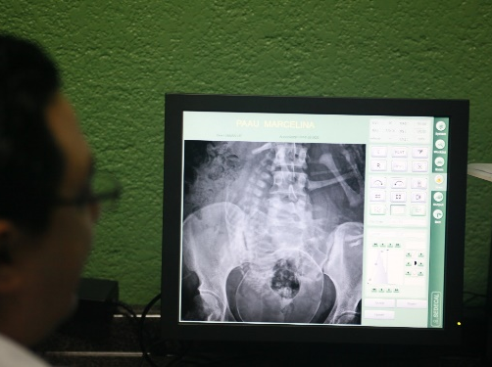
One digital x-ray system will serve a population of 50,000 or more for the better part of two decades if properly maintained. The primary beneficiaries of this global grant would be the rural and economically marginalized people in Guatemala. Diagnostic radiology services provides local physicians in community hospitals/clinics with diagnostic testing results that assist in the proper treatment of such diseases as fractures/sprains, asthma, pneumonia, congestive heart failure and tuberculosis.
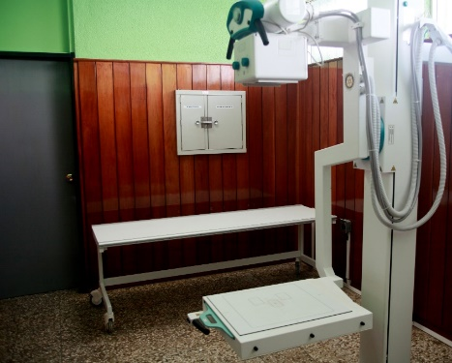
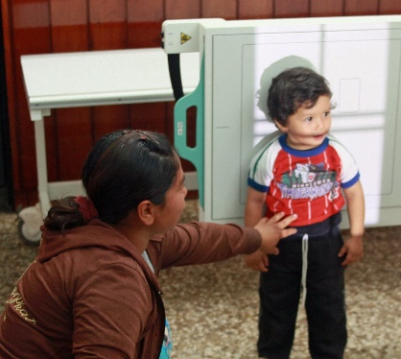
Benefit:
The Global Health Initiative reports that Guatemala is Central America’s most populous country, with 14.3 million people, of which about 40% are of indigenous (Mayan) descent. Guatemala has a national poverty rate exceeding 50% and a rate of extreme poverty of 15%. While 46% of the total population lives in rural areas, 72% of the extremely poor live in rural areas. Despite its middle-income status, Guatemala’s health outcomes compare unfavorably with those of other much poorer countries.
Sustainability:
Information from the x-ray equipment and the monthly statistics from the site will be used to evaluate the operation of the equipment. Radiology technicians will be responsible for collecting information for the supervising radiologist, through the Ministry of Health. Guatemalan Rotarians will provide information to District 6440 Rotarians. The host will be responsible for monitoring and evaluation of this project. The Ministry of Health is responsible for monitoring the operational aspects of the equipment and the local hospital/clinic management.
Overall outcome & Impact
Better health outcomes will result from more timely and accurate diagnosis of conditions. Population health and tracking of various epidemiological conditions will be improve due to more comprehensive public health records. . Families and socio-economic conditions will benefit, and economic productivity enhanced, by providing access to local clinics; they no longer will have to take time off work and travel many miles for X-ray services. Because local citizens will be trained as radiology operators, jobs will be created and Guatemala’s economy will benefit.

